Order Form – For replacement rollers to suit your transom

Date: | Quantity: | 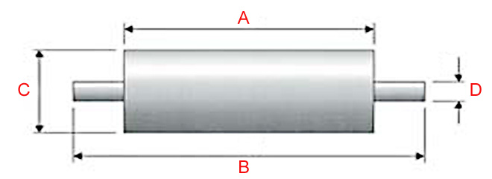 |  |  | Roller Dimensions
 |  |  |  |  | A
Delivery: | Order No: |  |  |  | B
 |  |  |  |  | C
 |  |  |  |  | D
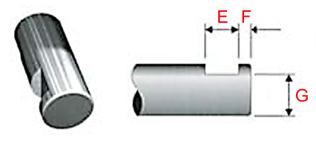  Type 1 |  | 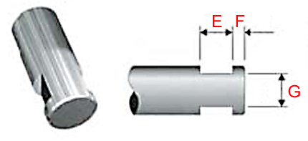  Type 2 |  |  | 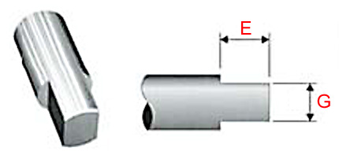  Type 3
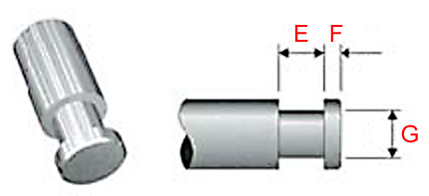  Type 4 |  | 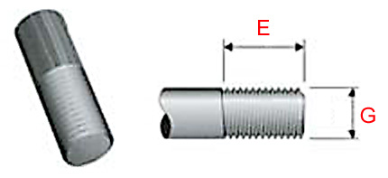  Type 5 |  |  | 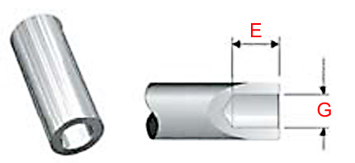  Type 6
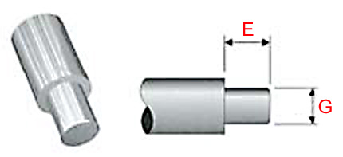  Type 7 |  | Type Number: |  |  | IBI Ltd  Unit A1, The Sidings,  Station Road,  Ampthill Industrial Estate,  Ampthill,  Beds MK45 2QY  Tel: 01525 840800  Fax: 01525 840900  Email: Info@ibiuk.com
 |  | Spindle  Dimensions: | E
 |  |  | F
 |  |  | G

